Apply filters to SQL queries

Project description
This project focuses on filtering out data while using SQL databases e.g. SELECT, AND, FROM and BETWEEN to improve efficiency by only showing data that you currently need and in situations where time is a factor, using filters can also reduce load times and display only the information needed.

Retrieve after hours failed login attempts
The project mentions that there has been suspicious log in attempts after hours and requires you to make a SQL query to gather information about the suspicious log in attempts.
In the lab in mentions log in attempts after 18:00. To find this information as the course and lab has shown I will use the following query:

SELECT *
FROM employees
WHERE login_attempts >= ’18:00’;

This returns all log in attempts made after the time “18:00”, here is an example of the provided output.

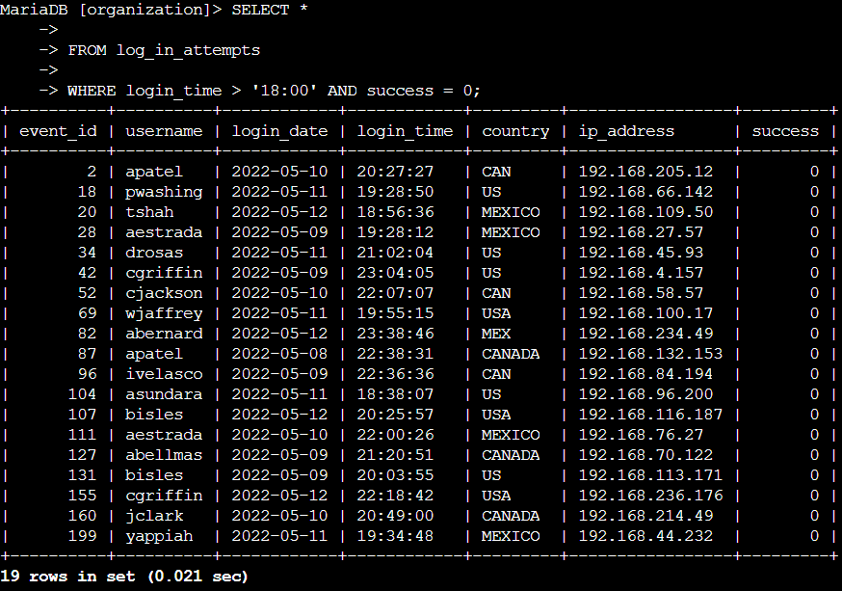

Retrieve login attempts on specific dates
The project asks to follow up on login attempts next, we will need to make a new query and apply filters to see login attempts from the dates for 2022-05-09 or 2022-05-08.

Since I am expected to find two separate dates in the same table of contents I will need to use the OR operator so that it will return 2022-05-09 or 2022-05-08.
The following query needed for this is:

SELECT *
FROM log_in_attempts
WHERE login_date = '2022-05-08' OR login_date = '2022-05-09';

This returns all login attempts made on both 2022-05-08 and 2022-05-09, here is a snippet of the provided output.

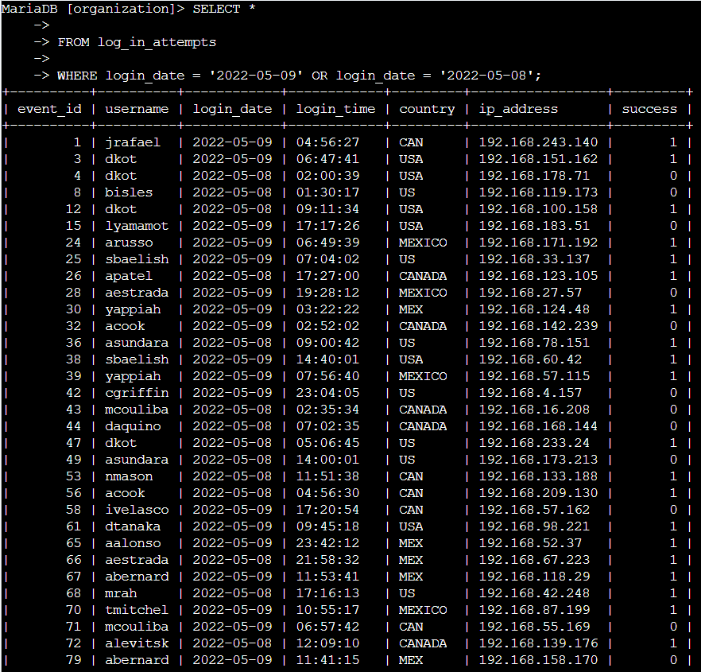

Note: The query returned 75 rows in the set but to ensure the ability to read the provided image I chose only to include a portion of the rows.

Retrieve login attempts outside of Mexico
The project now requires me to focus on login attempts made outside of Mexico. As you can see from the previously provided images under “country” you may see there is rows with both “MEX” and “MEXICO”. I will need to use the correct filters to make sure to include both.
The following query needed for this request is:

SELECT *
FROM employees
WHERE NOT country LIKE ‘MEX%’;

Note: I feel this query needs clarifying. Since this part requires you to find login attempts made outside of Mexico we need to use the NOT operator, this will show us every login attempt that did not occur from Mexico. The LIKE operator is used with the wildcard operator “%” since using these together in the query “LIKE ‘MEX%’” will exclude any rows containing both MEX and MEXICO.

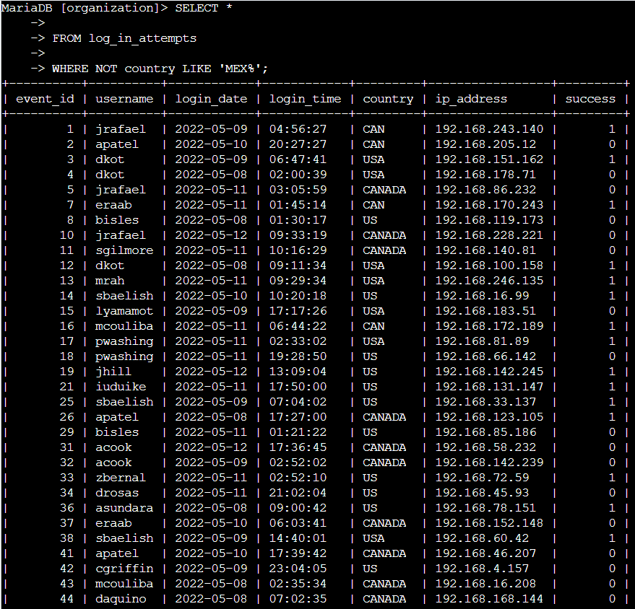

Retrieve employees in Marketing
For the next task I am told it is my responsibility to find the machines belonging to the Marketing department in the East offices for security updates.

For this the query I need to make must include the department and the offices with a wildcard:

SELECT *
FROM employees
WHERE department = ‘Marketing’ AND office LIKE ‘East%’;
Note: As seen in the query above, I filtered for only the Marketing department and then further filtered with the AND operator to filter for offices starting with East.

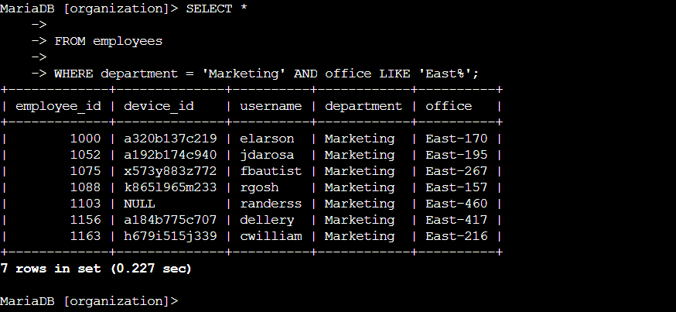

Retrieve employees in Finance or Sales
Similar to the above example the project says that I need to filter again but for both the Finance Department and the Sales department, the same reason as before applies here now too, the reason is for a security update.

For this query I will need to OR operator so the query knows to get the information needed from both departments, the AND operator here would cause a syntax error because it would require both conditions to be true but each employee only belongs to one department:

SELECT *
FROM employees
WHERE department = ‘Finance’ OR department = ‘Sales’;

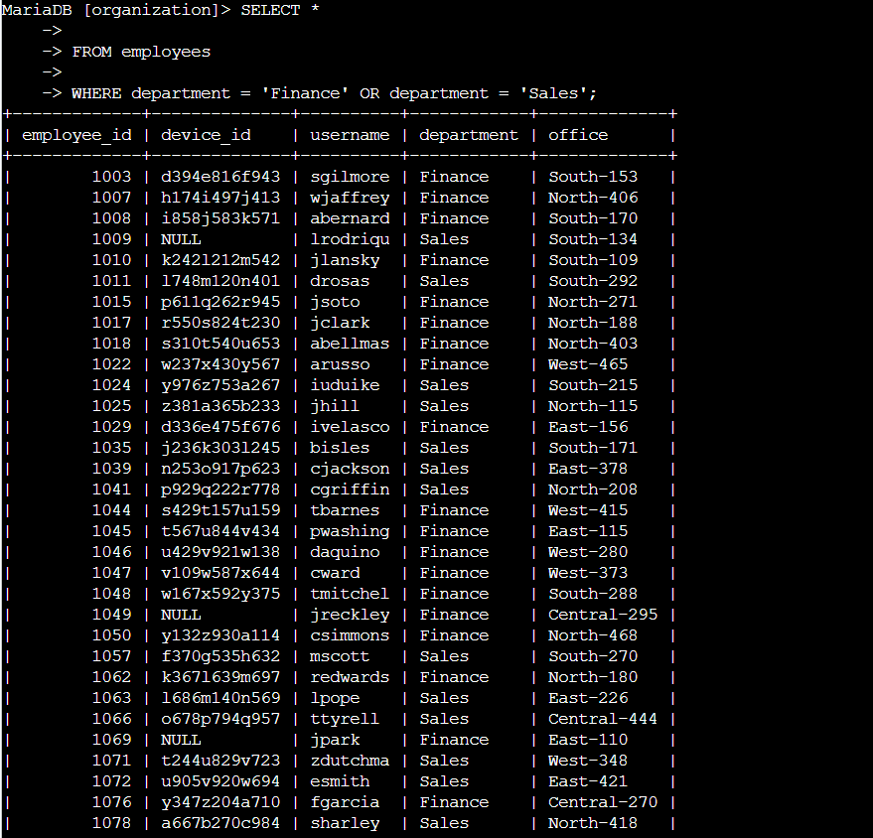

Retrieve all employees not in IT
The project informs me that the employee machines need one more update but the IT department has already received this update and needs to be excluded from the query. To do this I will simply use the NOT operator again and select departments and give the condition ‘Information Technology’ so the query knows to return all employees except IT.

SELECT *
FROM employees
WHERE NOT department = ‘Information Technology’;

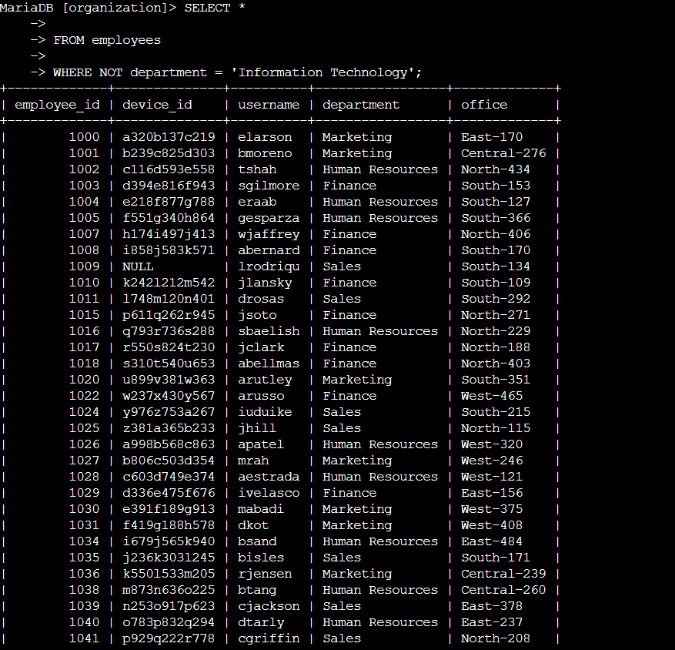

Summary
This project shows how filters can be applied for efficient queries, and to help show only the information needed for any given task. In the above tasks you needed to filter for login times, locations and filter for departments that need updates to relevant machines. By applying operator like AND, OR, LIKE and NOT I was able to achieve this and query the correct information I needed to complete the tasks and investigate the times and dates of login times and to also check to see what machines in departments needed security updates.

